**SEAT HEATING SYSTEM**

**Introduction: -**

The winter weather kicks into high gear, car owners might want to do a little extra work to make sure their cars are comfortable. Many believe that a car has to come with heated seats.

It can take a while for a heater to warm up an entire vehicle. Heated seats simply need to warm up the seat itself, so you’ll begin to feel warm almost immediately.

**Abstract**: -

The heat control system is basically used to control the temperature of the car seat. When a user or the driver of the car sits on the car, the button sensor is activated. After that, the user gets to turn on the heater. The temperature sensor continues to monitor the temperature and sends analog values to the microcontroller. The microcontroller processes the analog input of the temperature sensor and outputs the temperature value via serial communication. All the activities of the control system are done on a microcontroller called Atmega328

**Research: -**

***Why it is important to have heated seats?***

Heated seats are usually more effective in areas with a mild cold rather an extremely severe cold, otherwise they may have to be used in tandem with the car heater.

***How sensors keep you safe?***

The longer the seat cushion stays on the hotter it gets. If it were to stay on for too long it would get hot enough to become uncomfortable or even dangerous to sit in. It could even start a fire in the cushions. To prevent this, most car seat heaters have a thermostat. The thermostat measures the temperature in the cushion. When it reaches certain temperature the thermostat sends a signal automatically turning off the relay unit until the seat cools down a bit.

### **Objective: -**

* To detect person sitting in car with help of button sensors.
* To display the temperature set by user.

### **Features: -**

* Heated seats simply need to warm up the seat itself so instant heating takes place.
* The interior of the car is till fairly could because only seats are heating.
* Heated seats can be turned on individually so drivers and passengers well be able to control their own temperatures.

**Block diagram: -**

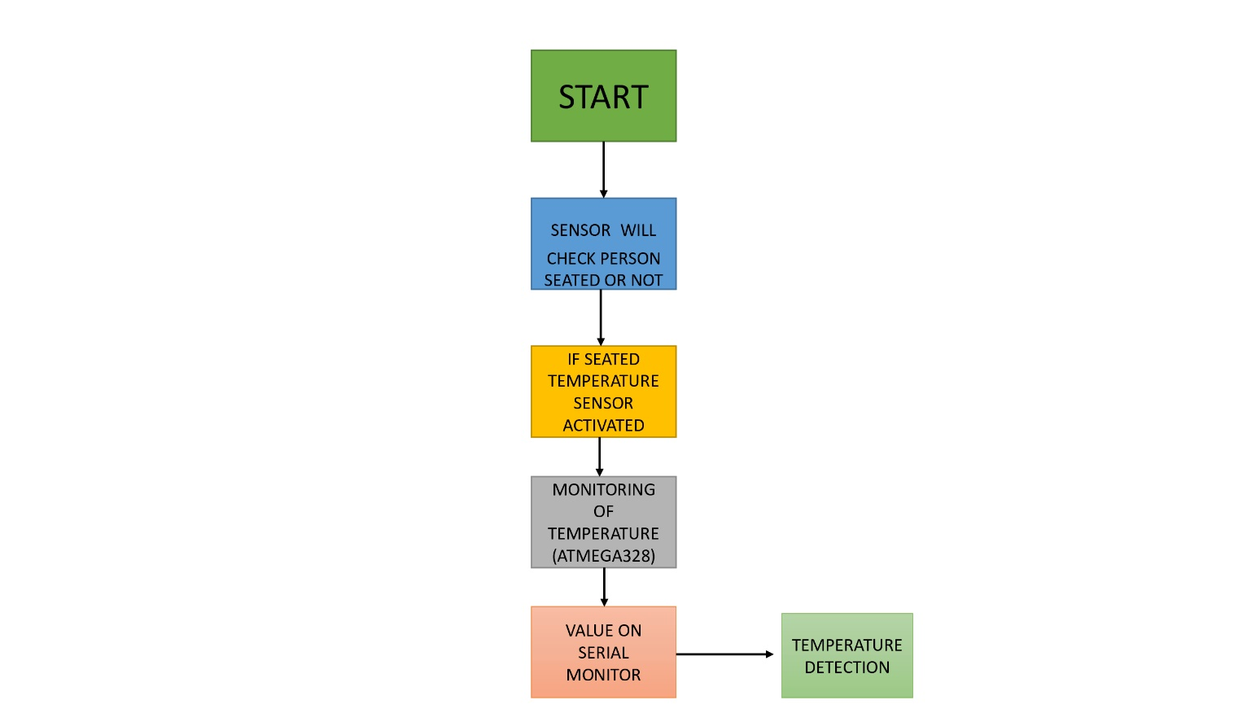

**Simulation: -**

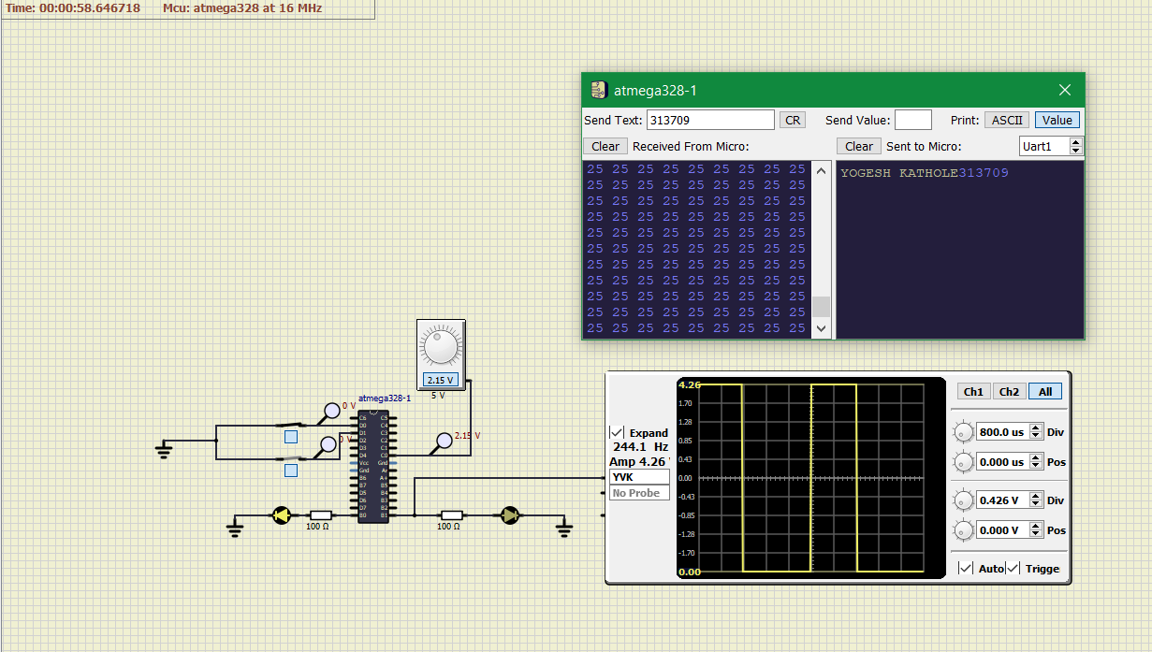**In action when OFF**

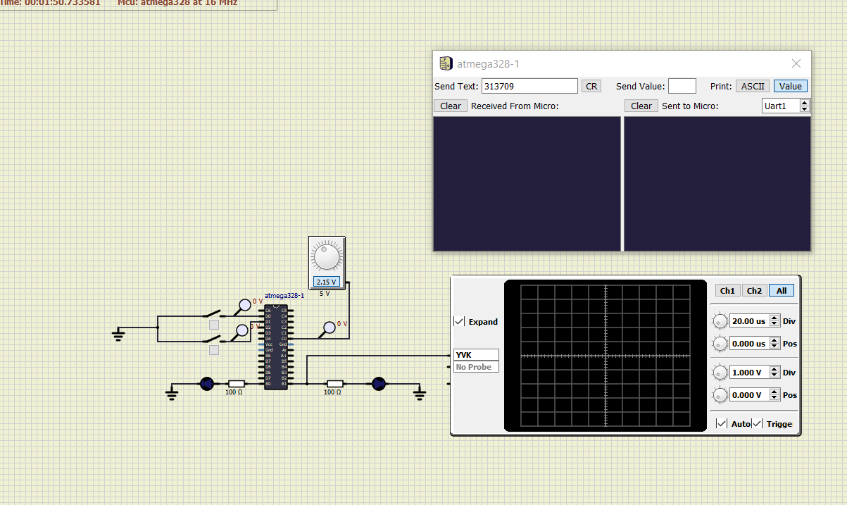

**In action when ON**